ProCp Project Plan

Artemiy Chervinskyy, 3522644

Robert Andeescu, 3527638

Ana Cirnu, 3644197

Andrei Fruijna, 3524787

Qi-Mo Lin, 3603296

Ignas Apsega, 3620557

# 

# **Project statement:**

**a. Client:** Joe Laro

**b. Project leader:** Artemiy Chervinskyy. **Team members:** Ana Cirnu, Robert Andreescu, Andrei Frujina, Qi-Mo Lin, Ignas Apsega

**c. Current situation:** The airport’s management team has no automated or viable means to properly allocate resources, such that an optimal flow of the baggage handling system would be ensured.

**d. Problem description:** The client requested to create a simulation of the airport baggage management system. Our application will simulate the journey of the luggage and the baggage sorting area of the airport which is capable of moving pieces of luggage to the plane.

1. **Pre-sprint task division:**

Artemiy: framework research, implementation

Robert: UML diagrams design, implementation

Ana: UML diagrams design, implementation

Andrei: UML diagrams design, implementation

Qi-Mo: framework research, implementation

Ignas: framework research, implementation

1. **Sprint 1:**

**Sprint goal:** The end goal of this sprint is to build an application that can showcase to the client the look and feel of the final app and also portrait a basic version of the main features of the complete product. It should feature the following requirements:

* The result of a given simulation, represented in the form of statistics, will be shown at the end of the simulation.
* The application starts with only one straight baggage belt and runs like so, with no option to change the belt system yet.
* The user will be able to enter the number of planes, passengers, and pieces of baggage per simulation before they start the simulation. These settings cannot be altered during the run of the simulation.
* The simulation will be finite.

**Phasing:**

State at the beginning of the sprint:

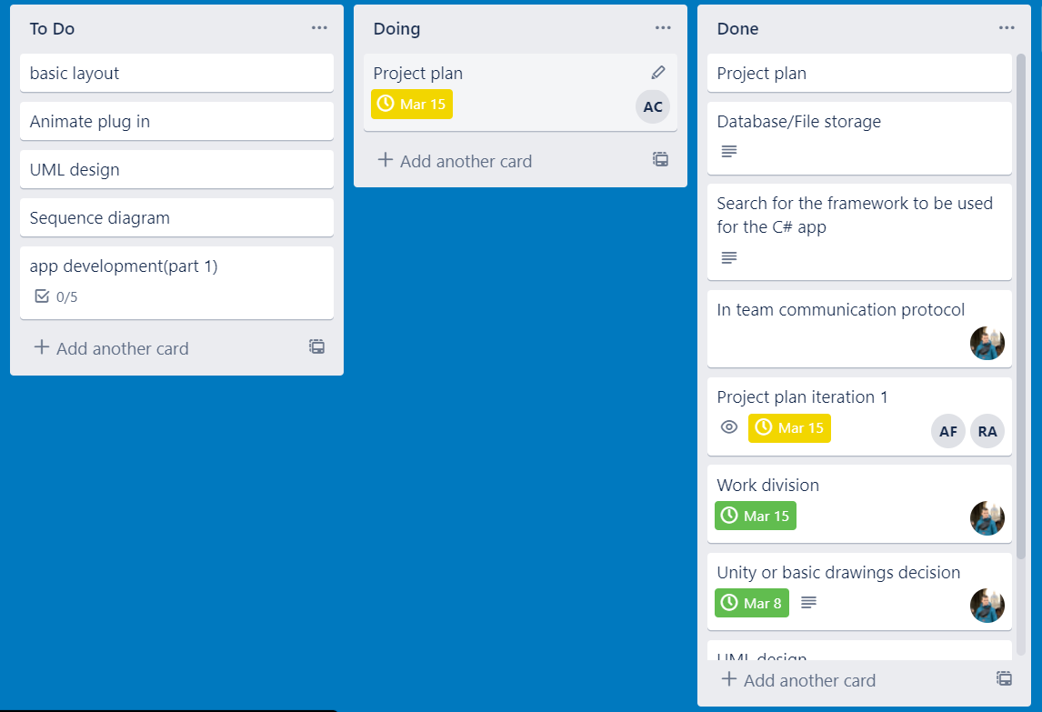

### Week 1

**Goal:** Define the Simulation area (part of the app that will be displaying the airport).

**Steps to be taken:**

1. Create a draft version of the UMLs
2. Belt drawing in the picture box
3. Creating a component of 3 picture boxes communicating together
4. Control start of the app ( functionality of “Start” button)
5. Define simulation objects such as :
   1. Piece of baggage
   2. Passenger

**Deliverables:** none

### Week 2

**Goal:** Make documentation for the current solution, support it with UMLs, add minor improvements

**Steps to be taken:**

1. Define class relation in the existing solution
2. Recreate UMLs in case if needed
3. Add input fields to the current solution

**Deliverables:** none

### Week 3

**Goal:** improvement phase

**Steps to be taken**: to be defined

**Deliverables:**

1. Final URS for sprint 1;
2. The final version of the plan for sprint 2;
3. Source code of proof of concept;
4. Proof of concept;
5. The updated version of work division report

### Week 4

**Goal:** Prepare the proof of concept

**Deliverables:** UML Class diagram(s) & non-trivial sequence diagram(s) of proof of concept

Work division:

|  |  |  |  |  |  |  |
| --- | --- | --- | --- | --- | --- | --- |
|  | Artemiy | Ana | Ignas | Qi-Mo | Robert | Andrei |
| Week 1 | Start implementing | Start implementing | Start implementing | Start implementing | Start implementing | Start implementing |
| Week 2 | Develop UMLs | Sequence diagram | Develop UMLs | Develop UMLs | Sequence diagram | Sequence diagram |
| Week 3 | App improvements+fixing bugs | App improvements+fixing bugs | App improvements+fixing bugs | App improvements+fixing bugs | App improvements+fixing bugs | App improvements+fixing bugs |
| Week 4 | UMLs adjusted + Design update for next sprint | Sequence diagram adjusted | UMLs adjusted | UMLs adjusted | Sequence diagram adjusted | Sequence diagram adjusted |